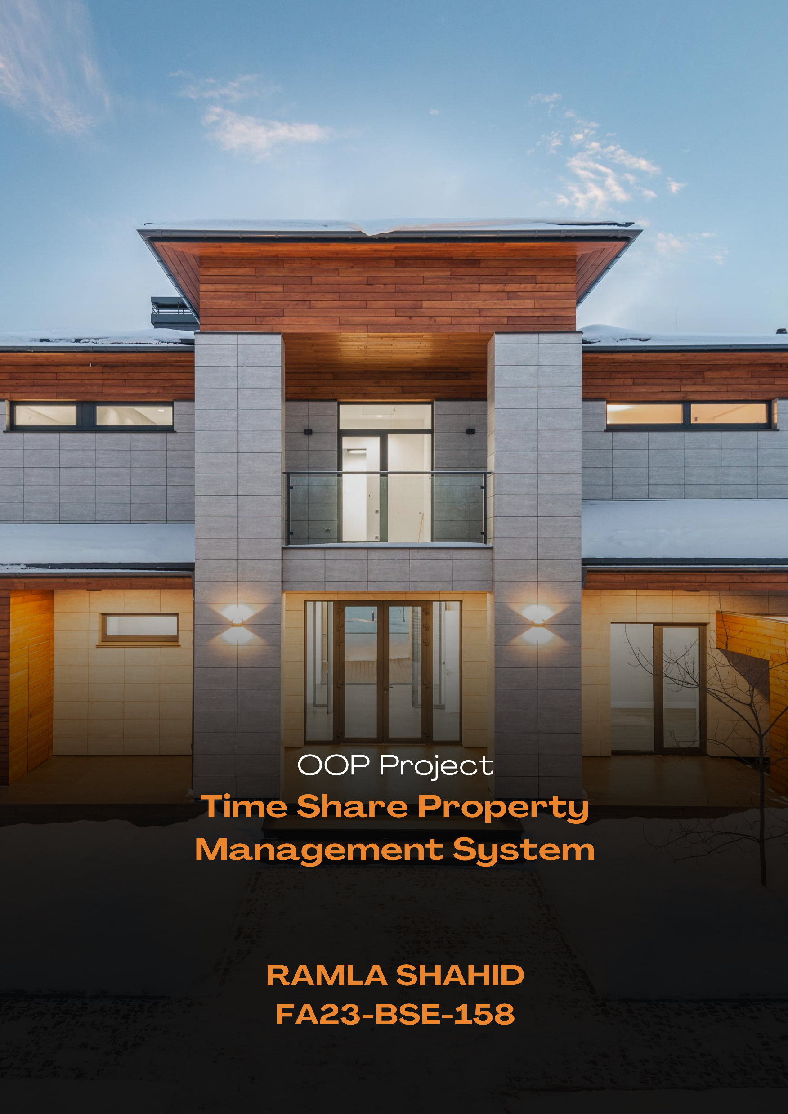**Name: Ramla Shahid**

**Reg. No: FA23-BSE-158**

**Classes:**

1. **User:**
   * Attributes: username, password, userType ("contributor", "regular", "admin")
   * Methods: getters and setters for attributes(getUserType)
2. **Property:**
   * Attributes: location, unitNumber, amenities, owner, price
3. **Reservation:**
   * Attributes: user (User object), property (Property object), dates (List<Date>)
4. **Login:**
   * Handles login functionality, verifying username and password against User data.
5. **Admin** (optional):
   * Can inherit from User class and provide additional functionalities specific to admins.
6. **Main**:
   * Launches the application and displays the main menu/dashboard based on user type.

**Functionalities:**

* **Login Page:** Allows users to enter credentials for authentication
* **User Management (Admin only):**
  + View all users
  + Edit user information
  + Delete users
* **Property Management (Regular Users):**
  + View all properties
  + Search properties based on location or other criteria
  + Buy a timeshare property (become contributor) by setting themselves as the owner of an existing property
* **Property Management (Contributors and Admins):**
  + View all properties
  + View reservations for a property
* **Reservation Management (Contributors and Regular Users who own properties):**
  + View availability calendar for their properties
  + Make a reservation for available dates on their properties
* **Admin-specific Functionalities (if using Admin class):**
  + Add new properties
  + Edit existing properties
  + Delete properties